Summary of work undertaken during the 80 days practice learning

Students are required to keep a BRIEF summary of significant pieces of work undertaken during their 80 days in practice. Students should not list every piece of work they do in their 80 days, but maintain a record of noteworthy pieces of work. It is recognised that there may be more than one intervention with a service user or carer at different stages of the placement. These should be written up as one case, not as separate cases. The case taken on and history will remain the same with the different interventions summarised.

Purpose
This record provides an overview of the type and range of work being undertaken. The summary enables the Practice Assessment Panel reader and the Practice Educator to ascertain whether the student is being provided with learning opportunities of a sufficient depth and breadth to meet the NOS and where this evidence may be. The summary of work undertaken is a valuable resource for the interim and final review meetings. An example is presented below. Summaries of work should not be much longer than this example.

Please ensure that ethnicity, age, gender etc are identified.

D
Case taken on:
D is a 39 year old white male, who has a long history of substance misuse. He had referred himself back to the addictions team for treatment of his illegal substance use. He is presently living with his parents, and has ongoing legal problems directly linked to his substance use.

My role/intervention:
I completed the re-assessment of D (unit 1, value 2), completed the treatment plan (unit 5 and 7 value 3, 5 ) and liaised with D and all the other professionals involved in that treatment plan (unit 17). I acted as Key Worker until D had completed his in-patient stabilization in the detoxification unit, and kept D’s treatment plan under review. I then referred him for weekly clinic appointments in order for him to complete his treatment within the community (units 7, 9,10,11). I mapped my developing knowledge, values and skills through discussion in supervision and with colleagues in the team (unit 14). I presented research findings underpinning best practice at a team meeting (unit 16, 17,18, 19 and 21).

The practice log

Although this is not assessed, students are required to keep a practice log throughout their 80 days in practice. Time should be made available within the day for this to be achieved. This is to enable students to develop and map their learning. Guidance for writing practice logs can be found in the appendices. The log will be invaluable to:

- Provide insight into learning
- Be drawn upon to discuss extracts in practice teaching and supervision sessions
- Discuss extracts at recall days,
- Use as a resource when writing assignments
- Plan the power point presentation of learning achieved during the placement.

Meaningful service user involvement 500 word statement

It is anticipated that much of the students’ learning will result from direct contact with people who user services and their carers. As such, service users and carers should be meaningfully involved in the learning opportunities provided. Please see Appendix 6 (below) for guidance.

Students, placement supervisors and practice educators are encouraged to consider how people who use services and carers can contribute to the student’s learning during the placement. Students are required to write a 500 word statement following the practice learning meeting which demonstrates how they intend to do this. This could be achieved in many different ways. Previous examples include service users and carers being involved in planning the student’s induction, offering a supervision session to explore the service user experience, evaluating aspects of the student’s practice or by sharing knowledge and expertise e.g. teaching the student sign language or offering a drug awareness session. The statement should be attached to the practice learning agreement and submitted in the portfolio.

Appendix 6 “Together we can” meaningful involvement of people who use services in practice learning

As illustrated below, the GSCC require that social work degree programmes involve people who use services in all aspects of their programme

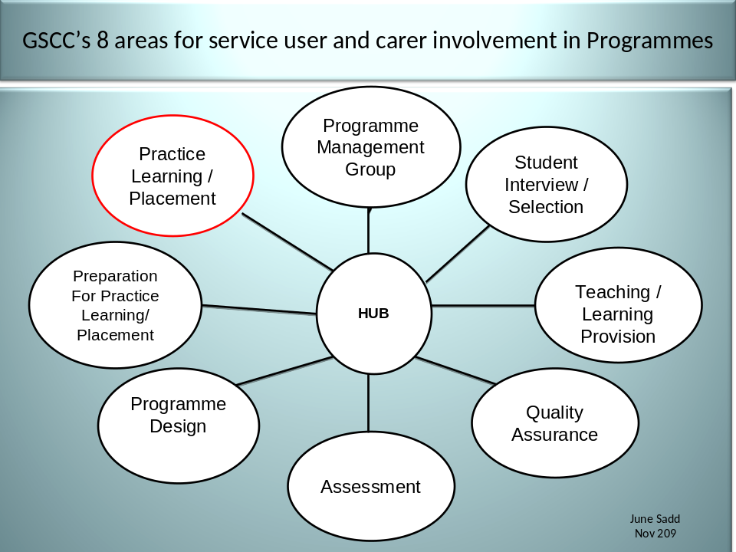

A service user colleague, who works closely with the BU programme has devised the model below to ensure that people who use services become meaningfully involved in practice learning.
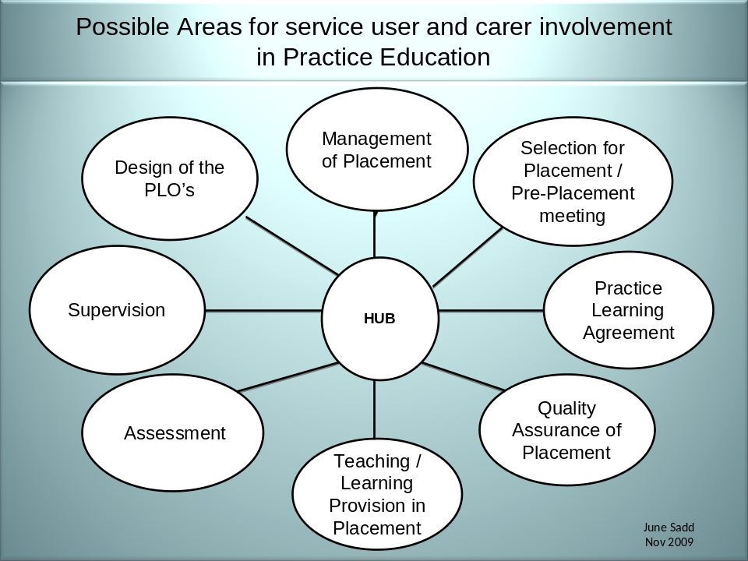

With reference to the model above, how do you think you could involve people who use services in your learning experience? Please discuss with your placement supervisor/practice educator. We will discuss in more detail during preparation for practice and at recall days.

You are required to write a statement (approximately 500 words) which should be attached to your practice learning agreement. The statement should set out how you intend to involve people who use services in your practice learning experience.

The following statements have been made where students have actively involved people who use services in their learning experience.

People who use services say:

- Being part of the student experience has helped the student and made me feel more worthwhile
- It’s like a key working session the other way around
- I was pleased to be able to make a contribution to ideas around learning opportunities
- I’ve changed my opinion of social workers! (At least this one!!)
- Students have time
- We devised and designed a mind map system to give feedback to the student
- The student sees me as a person and the gap in service they fill is invaluable

Students say:

- Users of services helped me to consider different learning opportunities
- This project has broadened my learning
- It’s helpful to learn directly from people who use services
- It has helped us understand the effect of the use of jargon and how it contributes to power differentials
- It takes time to grasp the concept of learning from people who use services – I’m training to be a professional!

Placement supervisors and practice educators say:

- It requires commitment from the student, people who use the service and us – so it does take more time
- Having the user of the service at the final review really helped the assessment
- Attending meetings addresses the power differential
- Contributing to the final report enables people who use services to identify ongoing opportunities to enhance the learning of future students

